**Angry Birds**

**Game Design Document**

Artem Anikieiev S18966

Vsevolod Kurochka s19317

# Section I – Game Overview

## Game Concept

This game is about destroying enemy’s fortifications and killing all enemies inside of them by launching different types of projectiles and using basic physics of flying and falling objects. Enemies are represented as Pigs and projectiles are represented as Birds.

## Feature Set

A lot of unique interesting levels.

Each Bird is played differently and have its own purpose in game

Physics helps us in beating the level

## Genre

Hyper-casual

## Game Flow Summary

Game is basically a set of levels from an easiest one to the hardest one. On each level player can achieve different scores and will be rewarded by stars for completing the level.

## Look and Feel

Game visuals are cartoonish and simple drawn. Gameplay is very simple – all controls can be done by one finger. Here are some examples of game visuals:

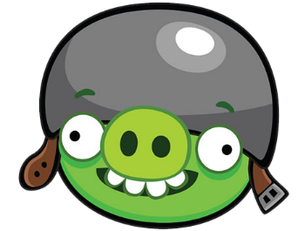

Corporal Pig

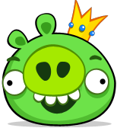

King Pig

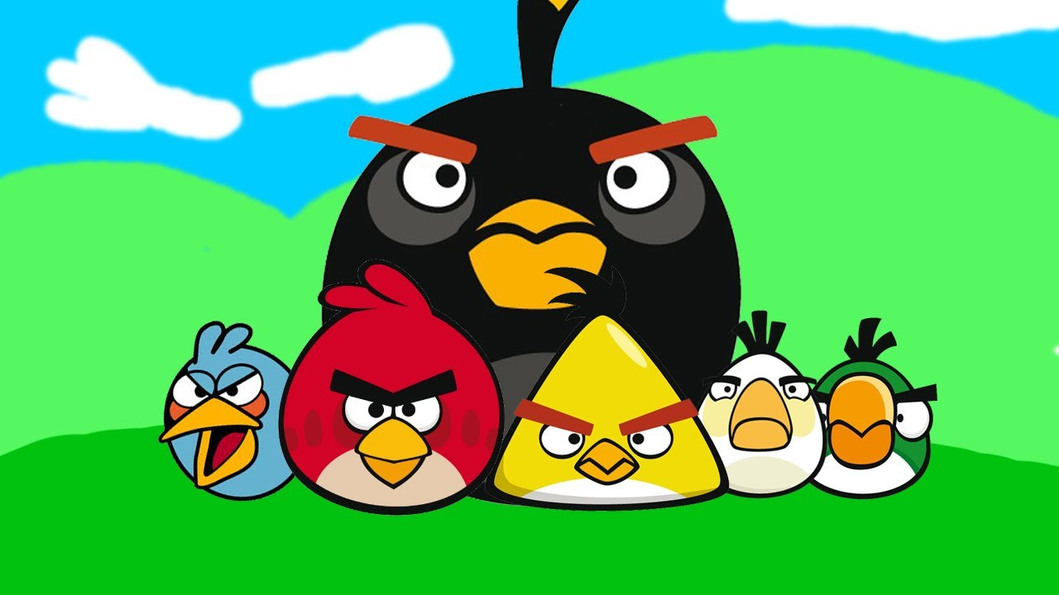

Some birds (Jay/Jake/Jim, Red, Bomb, Chuck, Matilda, Hal)

# Section II – Gameplay and Mechanics

## Gameplay

### Game Progression

Player progresses by completing levels.

### Level structure

On each level there is certain number of Birds, ‘’castle’’ with Pigs in it and a big Slingshot – Birds Launcher.

### Puzzle structure

There is a unique castle building, fully destroyable with Pigs in it.

### Objectives

Main objective is to kill all Pigs on a level by hitting them by Birds or castle elements.

Second objective is to get the best score for completing the level and to get three stars (which are calculated by score earned). Score can be earned by killing Pigs, destroying castle and using as little Birds as possible.

### Play flow

Player is given by a certain amount of Birds at the starting of a level. These Birds he can launch at castle, destroying it and killing Pigs within it. If player did not kill all pigs on level and number of Birds available is zero – Player lost and can replay a level, otherwise if Player had killed all Pigs then Player won, and score showed. If the score is not enough for a Player, he can replay level, otherwise move to next level.

## Mechanics

### Physics

Game supports Gravity and Kinematics.

### Movement

Birds are launched by Player with Force of Launch and Vector of launch and after that they fly by parabolic trajectory

### Objects

* Diamonds
* [Donuts](https://angrybirds.fandom.com/wiki/Donut)
* Hams
* Trophies
* [Treasure Chests](https://angrybirds.fandom.com/wiki/Treasure_Chest): the treasure chest is a Golden Egg.
* Fruit: Strawberries, Watermelons, Bananas, Apples
* Flags
* [Pick-axes](https://angrybirds.fandom.com/wiki/Pick-axe): First seen in [Mine and Dine](https://angrybirds.fandom.com/wiki/Mine_and_Dine). If they hit the ground, they dig up things, such as dynamite and boulders to help defeat pigs.
* [Beach Balls](https://angrybirds.fandom.com/wiki/Beach_Ball): In Poached Eggs [Level 2-2](https://angrybirds.fandom.com/wiki/Theme_2-2), the beach ball is a golden egg.
* Big [Rubber Ducks](https://angrybirds.fandom.com/wiki/Rubber_Duck" \o "Rubber Duck)
* [TNT Crates](https://angrybirds.fandom.com/wiki/TNT_Crates): Crates that explode upon contact.
* [Dice](https://angrybirds.fandom.com/wiki/Dice) Block: Decreases in number of dots each time damaged.
* [Smiley Face](https://angrybirds.fandom.com/wiki/Smiley_Face): First seen in [Theme 1-3.](https://angrybirds.fandom.com/wiki/Theme_1-3)
* [Greek Pillar](https://angrybirds.fandom.com/wiki/Greek_Pillar): Arguably the largest item in the game, pillars are strong items that support structures.
* Prehistoric Fruits
* Dinosaur Eye
* Ammonite Shell

### Opponents

Pigs are main opponents. They differ by their defensive abilities. Basically, they have 2 lives – soft hit takes 1 live, hard hit 2 lives

### Obstacles

There are different blocks of the castle to collide with. They differ by strength – Weak, Medium, Strong and different birds can destroy different blocks.

## Screen Flow

### Screen Flow Chart

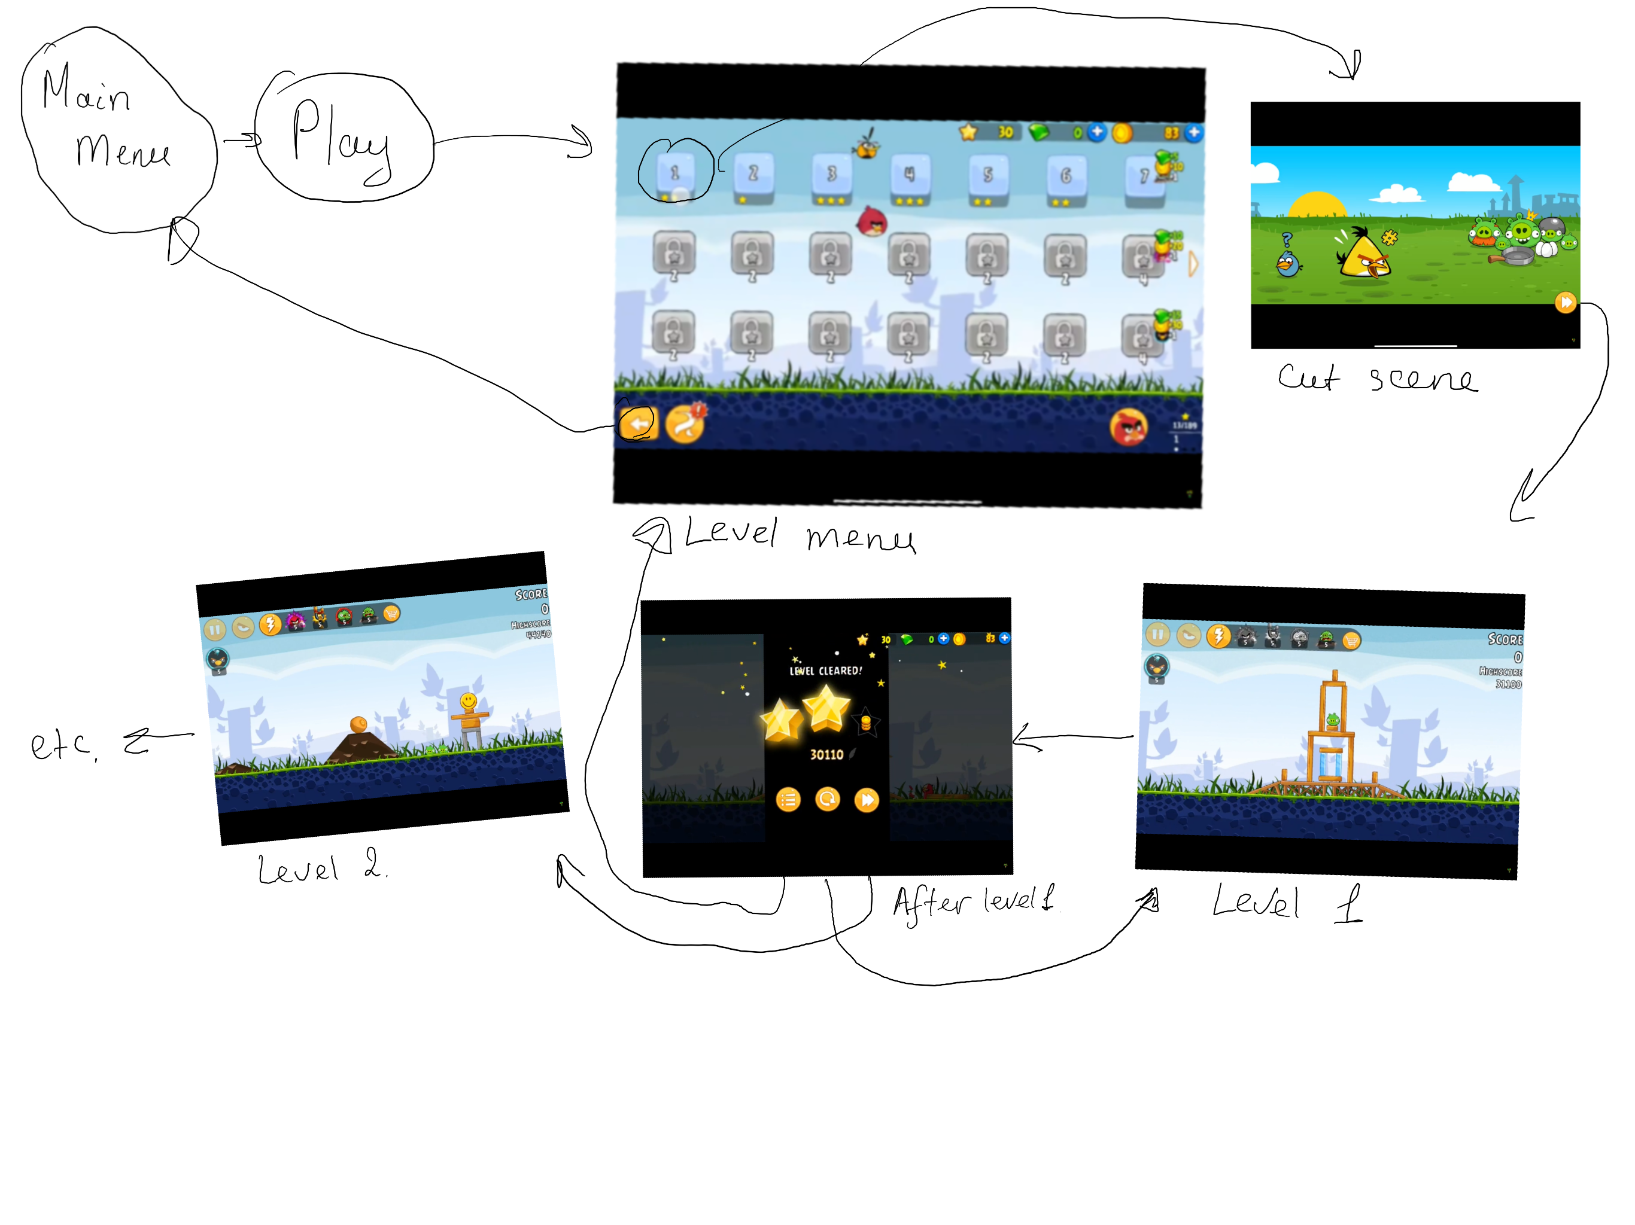

### Screen Description

#### Main menu screen

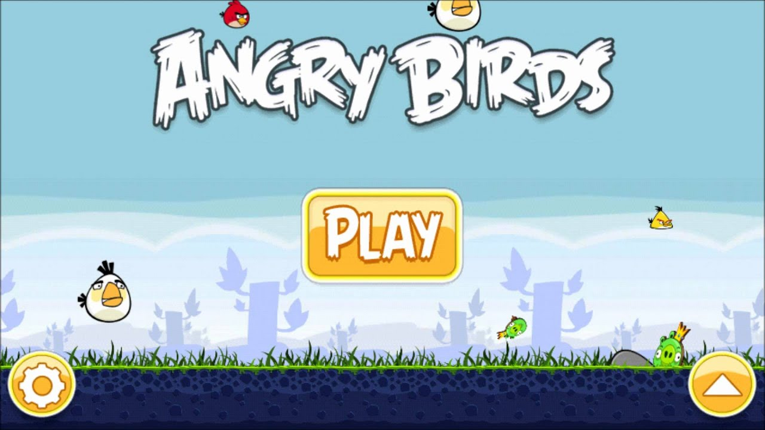

Starting point. Player can go over to the Level menu, to the Option menu or close the game

#### Option Screen

Menu, where player can regulate sound or turn it off.

#### Level menu screen

Menu, where player can choose the level which he want to start (if unlocked), either see progress.

#### After level menu

Menu, where player see which score did he reached, can choose one of the options: restart the level, return to the level menu, go over next level.

# Section III – Storytelling and Character

## Story and Narrative

### Back story

Once upon a time they were Birds and Pigs who are long-time enemies. Pigs decided to take Bird’s eggs to make omelet. Birds became angry and decided to bring their eggs back.

### Plot Elements

[*Golden Eggs*](https://angrybirds.fandom.com/wiki/Golden_Eggs), 35 scattered throughout the game, which unlocks [hidden levels](https://angrybirds.fandom.com/wiki/Golden_Egg_Levels) when collected. There is also the bonus [King Pig](https://angrybirds.fandom.com/wiki/King_Pig_(level)) level that contains 4 mini-gam

### Game progression

[*Tutorial*](https://angrybirds.fandom.com/wiki/Tutorial). It contains 15 levels.

[*Poached Eggs*](https://angrybirds.fandom.com/wiki/Poached_Eggs). It contains 63 levels, which must be conquered before any of the other episodes may be played.

[*Mighty Hoax*](https://angrybirds.fandom.com/wiki/Mighty_Hoax). It contains 42 levels.

[*Danger Above*](https://angrybirds.fandom.com/wiki/Danger_Above). It contains 45 levels.

[*The Big Setup*](https://angrybirds.fandom.com/wiki/The_Big_Setup)k. It contains 45 levels.

[*Ham 'Em High*](https://angrybirds.fandom.com/wiki/Ham_%27Em_High). It contains 45 levels and 3 Facebook levels.

[*Mine and Dine*](https://angrybirds.fandom.com/wiki/Mine_and_Dine). It contains 45 levels.

[*Birdday Party*](https://angrybirds.fandom.com/wiki/Birdday_Party). It contains 105 levels.

[*Bad Piggies*](https://angrybirds.fandom.com/wiki/Bad_Piggies_(Episode)). It contains 45 levels.

[*Red's Mighty Feathers*](https://angrybirds.fandom.com/wiki/Red%27s_Mighty_Feathers). It has 30 levels, 15 classic and 15 Egg Defender.

[*Short Fuse*](https://angrybirds.fandom.com/wiki/Short_Fuse). It has 45 levels.

[*Flock Favorites*](https://angrybirds.fandom.com/wiki/Flock_Favorites), a special episode. Contains 30 levels.

[*BirdDay 5*](https://angrybirds.fandom.com/wiki/BirdDay_5), a special episode. It contains 30 levels.

[*Surf and Turf*](https://angrybirds.fandom.com/wiki/Surf_and_Turf). It contains 45 levels.

[*Bird Island*](https://angrybirds.fandom.com/wiki/Bird_Island). It contains 21 levels.

[*Piggy Farm*](https://angrybirds.fandom.com/wiki/Piggy_Farm). Contains 45 levels.

[*Jurassic Pork*](https://angrybirds.fandom.com/wiki/Jurassic_Pork),. It contains 46 levels.

### Cut Scenes

#### Cut scene at the beginning

##### Actors

Red

Jay, Jake and Jim

Bomb

Chuck

Matilda

Small Pig x2

Corporal Pig

Foremen Pig

King Pig

##### Description

Eggs were stolen by Pigs

##### Storyboard

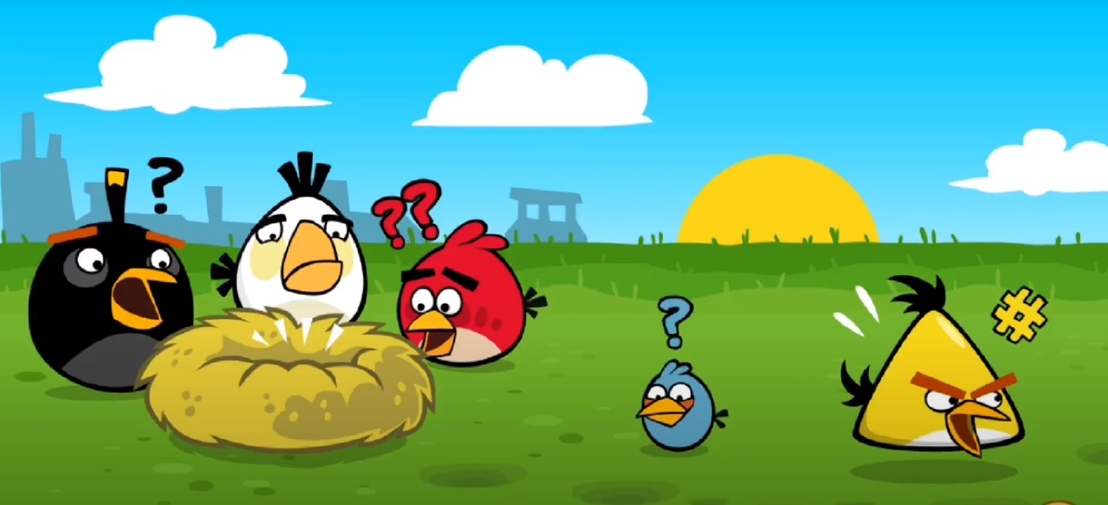

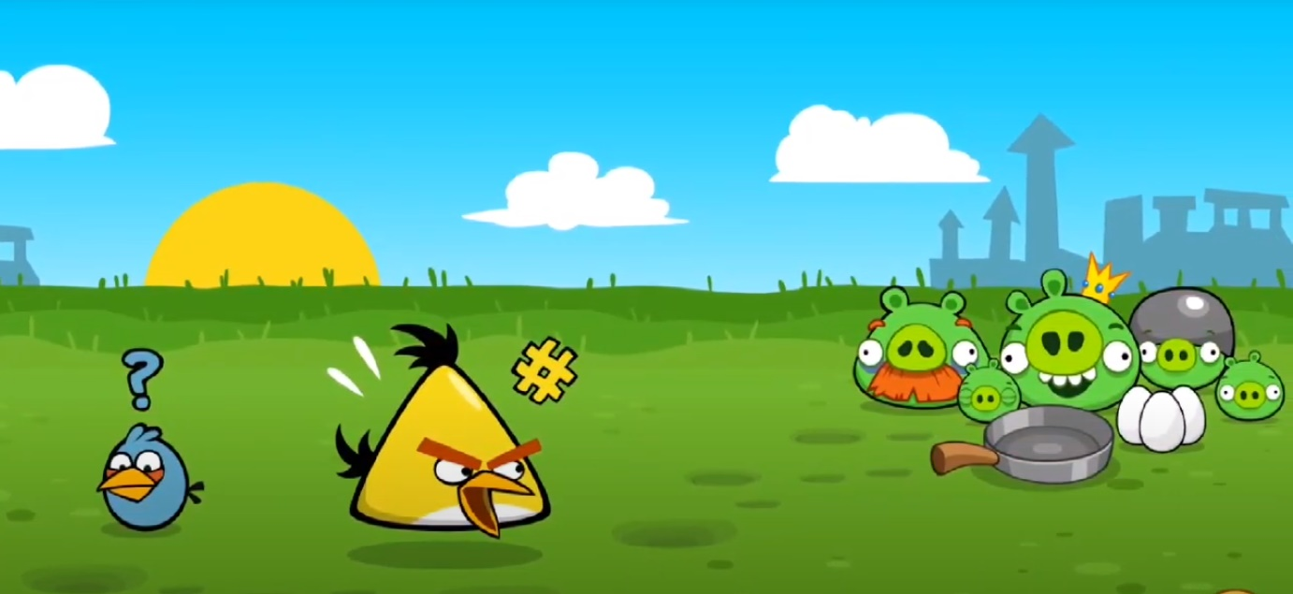

## Characters

### Birds

* [Red Bird](https://angrybirds.fandom.com/wiki/Red_Bird) [Red](https://angrybirds.fandom.com/wiki/Red) - No special power.
* [Blue Bird](https://angrybirds.fandom.com/wiki/Blue_Bird) [Jay, Jake, and Jim](https://angrybirds.fandom.com/wiki/The_Blues) - Splits into three smaller birds. Works best against the glass.
* [Yellow Bird](https://angrybirds.fandom.com/wiki/Yellow_Bird)[Chuck](https://angrybirds.fandom.com/wiki/Chuck) - Picks up speed and distance when tapped or clicked. Best against the wood.
* [Black Bird](https://angrybirds.fandom.com/wiki/Black_Bird)[Bomb](https://angrybirds.fandom.com/wiki/Bomb) - Explodes when tapped or shortly after impact. Best against the stone.
* [White Bird](https://angrybirds.fandom.com/wiki/White_Bird) [Matilda](https://angrybirds.fandom.com/wiki/Matilda) - Drops an egg bomb that explodes on impact when tapped and does great on wood.
* [Boomerang Bird](https://angrybirds.fandom.com/wiki/Boomerang_Bird) [Hal](https://angrybirds.fandom.com/wiki/Hal) - Comes back like a boomerang when tapped and does great on wood and glass.
* [Big Brother Bird](https://angrybirds.fandom.com/wiki/Big_Brother_Bird) [Terence](https://angrybirds.fandom.com/wiki/Terence) - No special abilities when tapped, but destroys materials with ease.
* [Orange Bird](https://angrybirds.fandom.com/wiki/Orange_Bird) [Bubbles](https://angrybirds.fandom.com/wiki/Bubbles) - Inflates to a huge size like a balloon when tapped/clicked or upon impact, then deflates a little later. Best against the wood.
* [Pink Bird](https://angrybirds.fandom.com/wiki/Pink_Bird) [Stella](https://angrybirds.fandom.com/wiki/Stella) - When tapped/clicked or upon impact, she makes bubbles around her which lift objects like blocks and pigs. The bubbles last for about 3 seconds.
* [Mighty Eagle](https://angrybirds.fandom.com/wiki/Mighty_Eagle) [Mighty Eagle](https://angrybirds.fandom.com/wiki/Mighty_Eagle) - You first launch a can of sardines and when it hits the ground, the Mighty Eagle will come down, destroying everything in its path and causing an earthquake, popping all pigs he missed and shoots back up into the sky, while also destroying anything else in his path

### Pigs

* [Small Pig](https://angrybirds.fandom.com/wiki/Minion_Pig): [Small Pig](https://angrybirds.fandom.com/wiki/Small_Pig" \o "Small Pig)
* [Medium Pig](https://angrybirds.fandom.com/wiki/Minion_Pig): [Medium Pig](https://angrybirds.fandom.com/wiki/Medium_Pig" \o "Medium Pig)
* [Large Pig](https://angrybirds.fandom.com/wiki/Minion_Pig): [Large Pig](https://angrybirds.fandom.com/wiki/Large_Pig" \o "Large Pig)
* [Corporal Pig](https://angrybirds.fandom.com/wiki/Corporal_Pig): [Corporal Pig](https://angrybirds.fandom.com/wiki/Corporal_Pig) – additional defense on head
* [Foreman Pig](https://angrybirds.fandom.com/wiki/Foreman_Pig): [Foreman Pig](https://angrybirds.fandom.com/wiki/Foreman_Pig" \o "Foreman Pig)
* [King Pig](https://angrybirds.fandom.com/wiki/King_Pig): [King Pig](https://angrybirds.fandom.com/wiki/King_Pig_(character)" \o "King Pig (character))
* [Leonard](https://angrybirds.fandom.com/wiki/Leonard): [Leonard](https://angrybirds.fandom.com/wiki/Leonard" \o "Leonard)

# Section IV – Levels

## Level 0

### Objectives

Kill 1 Medium Pig

### Introductory Material

Cut Scene at the beginning

### Physical Description

What is on level:

A Slingshot – left corner

3 Birds – Red (near slingshot)

1 Medium Pig (in a castle)

Castle:

4 small wooden platforms (2 vertical, 2 horizontal)

3 medium wooden platforms (all horizontal)

5 big wooden platform (4 vertical, 1 vertical)

2 glass platforms (vertical)

### Level Walkthrough

Direct Bird to the first highest big wooden platform

### Level View

### 

Figure 1. Level 0 - with walkthrough

## Level 1

### Objectives

Kill 4 Medium Pigs

### Physical Description

What is on level:

A Slingshot – left corner

5 Birds – Red (near slingshot)

4 Medium Pigs on the wooden platforms

3 medium stone platforms (vertical)

1 big stone platform (vertical)

4 medium wooden platforms (horizontal)

### Level Walkthrough

Direct Bird to the last wooden platform to kill last Pig. Next Bird direct to the first Pig on Platform. It will kill first and second Pig. Direct next Bird to the third Pig to kill the last.

### Level View

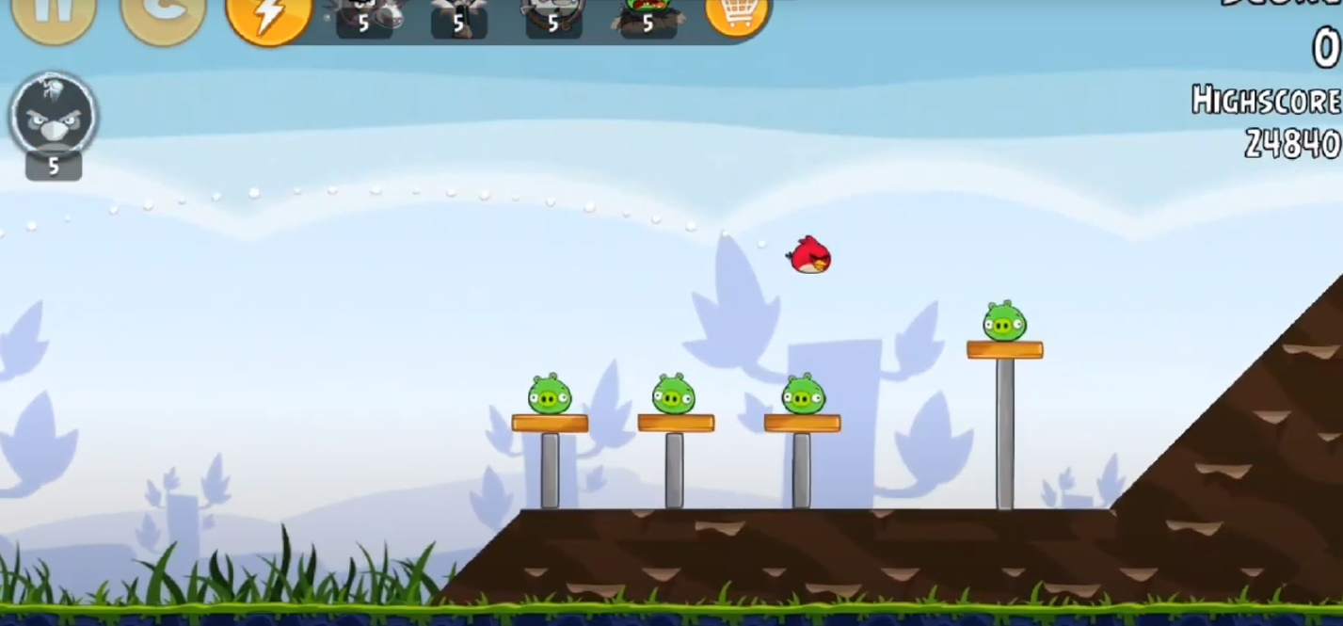

Figure 2. Level 1

# Section V – Interface

## Visual system

### HUD

Pause – go over the menu, which is alike to after level menu. Player can restart the level or return to level menu.



Additions – can be bought by player for real money or for gems(game currency), which will help to pass the level successfully

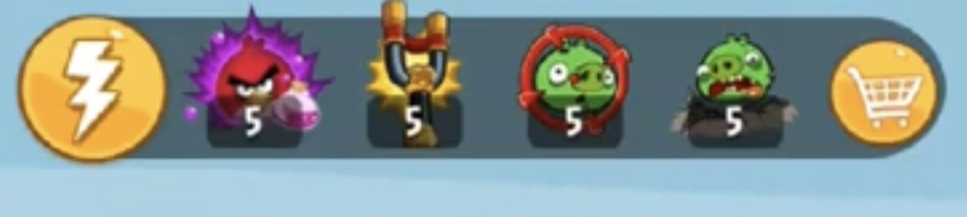

Score – showing the current score for level.

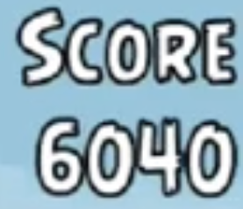

High score – showing the highest score reached by player for the current level

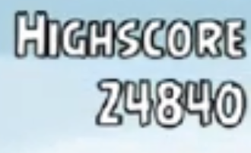

### Menus

Main menu – player choose go to level menu, go to option menu, or close the game.

Level Menu - Menu, where player can choose the level which he want to start (if unlocked), either see progress.

After level menu - Menu, where player see which score did he reached, can choose one of the options: restart the level, return to the level menu, go over next level.

Option menu - Menu, where player can regulate sound or turn it off.

### Rendering system

### Camera

Camera always follow the player (bird) which is flying, player can move the camera to see the level and constructions and pigs

### Lighting models

The game using global lighting.

## Control system

In the game you simply pull back the bird and release. Moving your finger up and down while pulling back can make the bird go higher, lower, farther, and closer. Also, all birds except the first one have a special ability that is activated by touching the screen.

## Help system

**Tutorial** is an episode in the original [*Angry Birds*](https://angrybirds.fandom.com/wiki/Angry_Birds), consisting of 15 levels. This episode is designed for new players of the game to introduce themselves to the birds and the [Power-Ups](https://angrybirds.fandom.com/wiki/Power-Ups). This episode must be completed before starting the game itself.

Levels 1-8 introduce six of the birds: [Red](https://angrybirds.fandom.com/wiki/Red), [Chuck](https://angrybirds.fandom.com/wiki/Chuck), [Bomb](https://angrybirds.fandom.com/wiki/Bomb), [The Blues](https://angrybirds.fandom.com/wiki/Jay,_Jake,_and_Jim), [Terence](https://angrybirds.fandom.com/wiki/Terence), and [Bubbles](https://angrybirds.fandom.com/wiki/Bubbles). The next six levels introduce each of the power-ups (Sling Scope, Power Potion, King Sling, Birdquake, and Shockwave) and how to use each of them (with unlimited use), and the final level lets the use of all the birds listed above and all of the power-ups to complete the level.

# Section VI – Game Art

## Visuals

### Concept Art

### Style guides

### 

### Characters

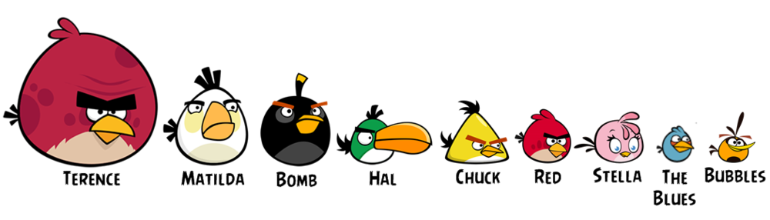

### Environment

The game was released on IOS, Android, Nokia, PSP, Windows phone.

### Cut Scenes

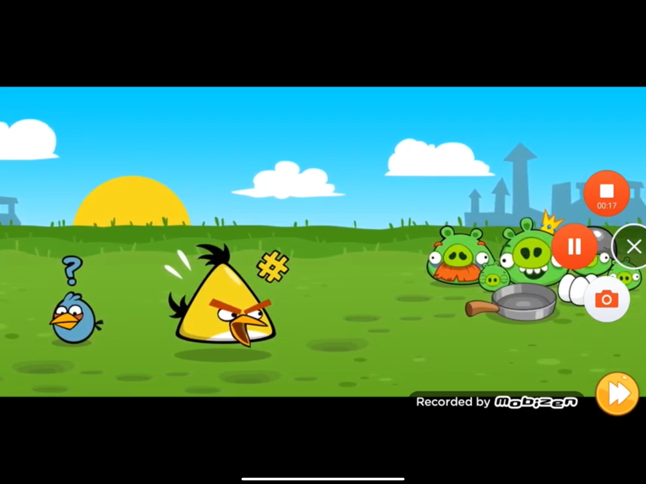

## Audio

### Music

The main theme of [*Angry Birds*](https://angrybirds.fandom.com/wiki/Angry_Birds_(game))  composed by Ari Pulkkinen.

### Table of Contents

1 Section I – Game Overview 2

1.1 Game Concept 2

1.2 Feature Set 2

1.3 Genre 2

1.4 Game Flow Summary 2

1.5 Look and Feel 2

2 Section II – Gameplay and Mechanics 4

2.1 Gameplay 4

2.1.1 Game Progression 4

2.1.2 Level structure 4

2.1.3 Puzzle structure 4

2.1.4 Objectives 4

2.1.5 Play flow 4

2.2 Mechanics 4

2.2.1 Physics 4

2.2.2 Movement 4

2.2.3 Objects 4

2.2.4 Opponents 5

2.2.5 Obstacles 5

2.3 Screen Flow 5

2.3.1 Screen Flow Chart 5

2.3.2 Screen Description 6

3 Section III – Storytelling and Character 6

3.1 Story and Narrative 6

3.1.1 Back story 6

3.1.2 Plot Elements 6

3.1.3 Game progression 6

3.1.4 Cut Scenes 7

3.2 Characters 8

3.2.1 Birds 8

3.2.2 Pigs 8

4 Section IV – Levels 10

4.1 Level 0 10

4.1.1 Objectives 10

4.1.2 Introductory Material 10

4.1.3 Physical Description 10

4.1.4 Level Walkthrough 10

4.1.5 Level View 10

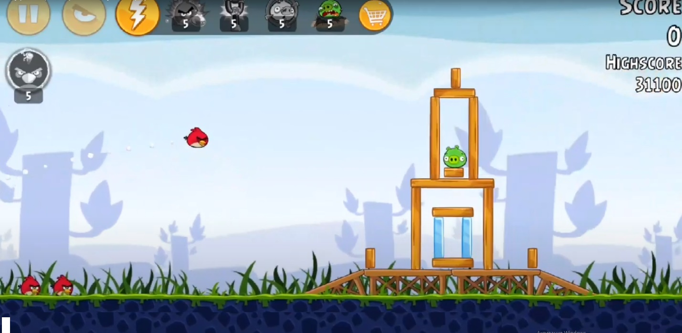 10

4.2 Level 1 10

4.2.1 Objectives 10

4.2.2 Physical Description 11

4.2.3 Level Walkthrough 11

4.2.4 Level View 11

5 Section V – Interface 11

5.1 Visual system 11

5.1.1 HUD 11

5.1.2 Menus 12

5.1.3 Rendering system 12

5.1.4 Camera 12

5.1.5 Lighting models 12

5.2 Control system 13

5.3 Help system 13

6 Section VI – Game Art 14

6.1 Visuals 14

6.1.1 Concept Art 14

6.1.2 Style guides 15

15

6.1.3 Characters 16

6.1.4 Environment 16

6.1.5 Cut Scenes 16

6.2 Audio 17

6.2.1 Music 17

Table of Contents 18

### 